Follow Me Project

Introduction and Data

The objective of this project is to demonstrate the knowledge adquired during the Deep Learning lesson. It consist of the training of a drone with pictures taken with the simulator, to make it capable of identifying and follow a specific person (hero).

A sample of pictures is provided in the lesson, however I took sets of pictures in different situations, following the suggestions of the lesson.

- The hero walking sorrounded by a crowd, with the drone taking pictures from different angles.

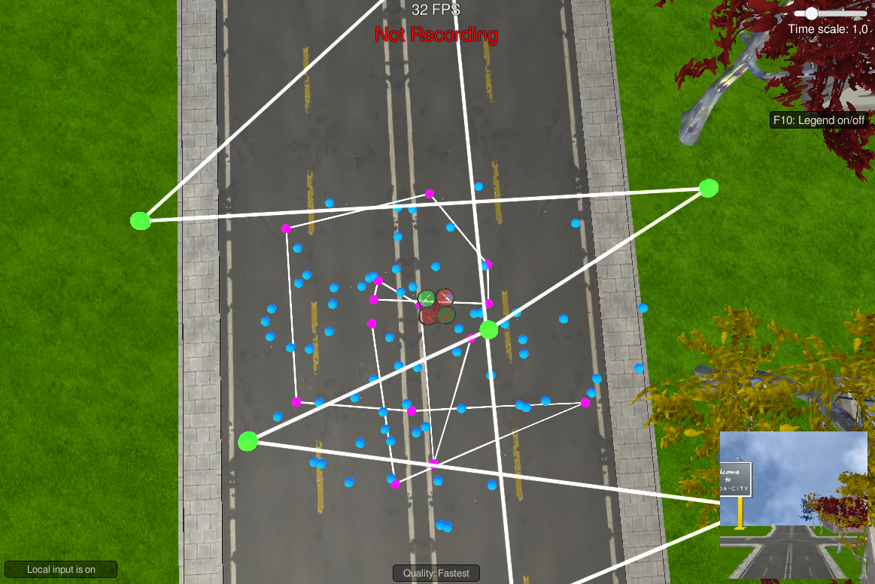

- A zig-zag route of hero and drone
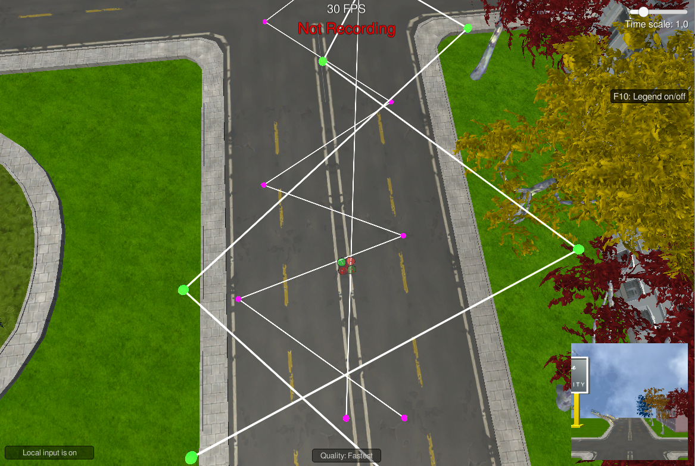
- A path of the drone through the world

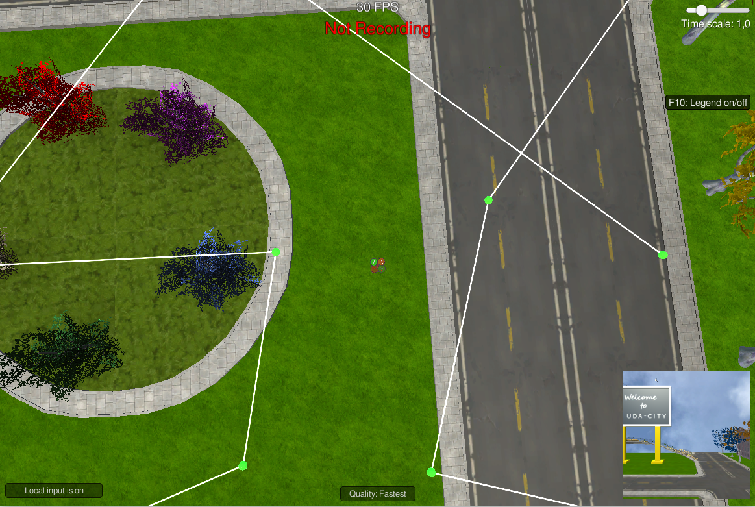

I took around 10.000 images, that after executing the preprocess_ims.py script, they became around 2.500.

CNN
A Convolutional Neural Network must be used in this project as far as we need to detect an specific “object” (hero) and also its position.
Like in the Segmentation Lab, the network consist of an encoder, a 1x1 convolutional layer and a decoder.
Thanks to the 1x1 convolution, the number of outputs in equivalent to the number of inputs, so compared to a fully connected layer, it keeps spatial characteristics.

Results of training
For my first try, I used the parameters used during the Segmentation Lab, with the images provided in the lesson, with a result not so bad, taking into account that I didn’t do any change:

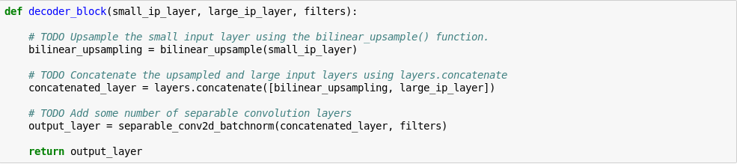
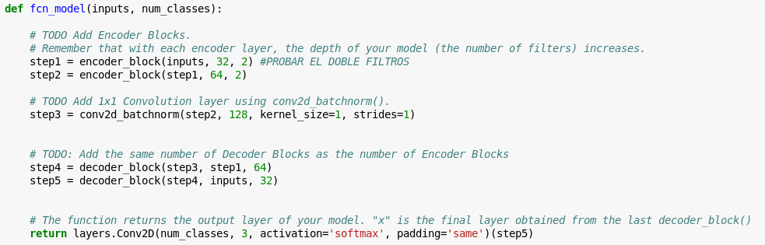
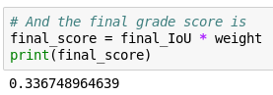

Hopefully, I had access to AWS as detailed in the lesson. I did that first try with my PC (without GPU) and took around 10 hours to execute.

To try to improve with more data, I mixed the images provided with the 2.500 I took by myself with the simulator. Again, without doing any change in the code:

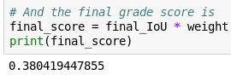

This time using AWS, which took a couple of hours to compute.
Close to the objective of the lesson, but still not enough. As mentioned, a big increase in the samples wouldn’t necessary mean a big increase in the results.

